1. **SUMMARY OF APPLIED PATCHES AND FIXES**

This section covered the security patches and configuration changes applied to the PNexus Web Application environment in response to vulnerabilities identified during the recent network vulnerability scan using Nmap and NSE scripts.

*Code Legends:*

1. Codes with negative sign tells that the line(s) were removed
2. Codes with positive sign tells that the line(s) were added
3. Codes without signs means that there were no changes made
4. **Vulnerable JS Library (Outdated)**

Updated jQuery to the latest version to patch known vulnerabilities and prevent exploitation via outdated libraries.

|  |
| --- |
| Modified: header.php |
| Risk=High, Confidence=Medium (1) |
| **Vulnerabilities:** CVE-2022-24785, CVE-2022-31129, OWASP_2021_A06, CWE-1395 |
| - <script src="js/jquery-1.12.4.min.js"></script>  + <script src="https://code.jquery.com/jquery-3.7.1.min.js"></script> |

1. **CSP Header Not Set & Missing Anti-clickjacking Header**

Added Content-Security-Policy (CSP) header to restrict frame embedding and reduce risk of clickjacking and content injection.

|  |
| --- |
| Modified: .htaccess |
| (a) Risk=Medium, Confidence=High (1) ; # CSP Header Not Set |
| **(a) Vulnerabilities:** CWE-693, OWASP_2021_A05, OWASP_2017_A06 |
| (b) Risk=Medium, Confidence=Medium (2); # Missing Anti-clickjacking Header |
| **(b) Vulnerabilities:** WSTG-v42-CLNT-09, OWASP_2021_A05, OWASP_2017_A06, CWE-1021 |
| +<IfModule mod_headers.c>  + Header always set Content-Security-Policy "  + frame-ancestors 'self'; #prevent changing frame-source to external URI  + "  +</IfModule> |

1. **Absence of Anti-CSRF Tokens**

Enabled CSRF protection in CodeIgniter config to safeguard forms from cross-site request forgery attacks.

|  |
| --- |
| Modified: application/config/config.php |
| Risk=Medium, Confidence=Low (2) |
| **Vulnerabilities:** OWASP_2021_A01, WSTG-v42-SESS-05, OWASP_2017_A05, CWE-352 |
| +$config['csrf_protection'] = TRUE;  +$config['csrf_token_name'] = 'csrf_token_pnexus';  +$config['csrf_cookie_name'] = csrf_cookie_pnexus'';  +$config['csrf_expire'] = 7200;  +$config['csrf_regenerate'] = TRUE;  +$config['csrf_exclude_uris'] = array(); |

1. **Server Leaks "Server" Header**

Configured Apache to suppress the "Server" header to prevent revealing backend technology details to potential attackers.

|  |
| --- |
| Modified: apache/conf/httpd.conf |
| Risk=Low, Confidence=High (1) |
| **Vulnerabilities:** OWASP_2021_A05, OWASP_2017_A06, WSTG-v42-INFO-02, CWE-497 |
| +ServerTokens Prod  +ServerSignature Off |

1. **Application Error Disclosure**

Replaced detailed error output with generic message to prevent leaking sensitive debug info to users.

|  |
| --- |
| Modified: application/view/errors/error_handler.php |
| Risk=Low, Confidence=Medium (5) |
| **Vulnerabilities:** WSTG-v42-ERRH-02, WSTG-v42-ERRH-01, CWE-550, OWASP_2021_A05, OWASP_2017_A06 |
| - echo $exception;  + echo "An error occurred. Please contact support."; |

1. **Cross-Domain JS Source File Inclusion**

Strengthened CSP policy to restrict all resource types to the same origin, blocking potential XSS through cross-domain inclusions.

|  |
| --- |
| Modified: .htaccess |
| Risk=Low, Confidence=Medium (5) |
| **Vulnerabilities:** OWASP_2021_A08, CWE-829 |
| <IfModule mod_headers.c>  Header always set Content-Security-Policy "  + default-src 'none'; # Block all content by default;  + img-src 'self'; # Allow images only from the same origin  + connect-src 'self'; # Allow XHR, WebSocket, and EventSource connections only to the same origin  + object-src 'none'; # Prevent embedding external objects (e.g., Flash, PDFs, videos)  frame-ancestors 'self';  + base-uri 'self'; # Only allow the original server url tag to reference same-origin URLs;  + form-action 'self'; # Allow form submissions only to the same origin;  + upgrade-insecure-requests; # redirect all http (insecure) requests to https (secure)  "  </IfModule> |

1. **Debug Error Messages Disclosure**

Disabled PHP error display to hide internal application messages that could aid attackers in crafting attacks.

|  |
| --- |
| Modified: apache/conf/httpd.conf |
| Risk=Low, Confidence=Medium (5) |
| **Vulnerabilities:** OWASP_2021_A01, WSTG-v42-ERRH-01, OWASP_2017_A03, CWE-1295 |
| +php_flag display_errors Off |

1. **Server Leaks "X-Powered-By" Header**

Disabled expose_php and unset X-Powered-By header to conceal PHP usage and version from attackers.

|  |
| --- |
| Modified files: php.ini, .htaccess |
| Risk=Low, Confidence=Medium (5) |
| **Vulnerabilities:** OWASP_2021_A01, OWASP_2017_A03, WSTG-v42-INFO-08, CWE-497 |
| // php.ini  -expose_php = On  +expose_php = Off |
| // .htaccess  <IfModule mod_headers.c>  + Header unset X-Powered-By # prevents apache from displaying PHP versions in http response.  Header always set Content-Security-Policy "  default-src 'none';  img-src 'self';  connect-src 'self';  object-src 'none';  frame-ancestors 'self';  base-uri 'self';  form-action 'self';  upgrade-insecure-requests;  "  </IfModule> |

1. **X-Content-Type-Options Header Missing**

Added nosniff header to prevent MIME type sniffing, which could allow execution of malicious files.

|  |
| --- |
| Modified files: .htaccess, httpd.conf |
| Risk=Low, Confidence=Medium (5) |
| **Vulnerabilities:** CWE-693, OWASP_2021_A05, OWASP_2017_A06 |
| // .htaccess  <IfModule mod_headers.c>  # developer should explicitly specify the mime type (server should not guess it)  + Header set X-Content-Type-Options "nosniff"  Header unset X-Powered-By  <IfModule mod_headers.c>  Header unset X-Powered-By  Header always set Content-Security-Policy "  default-src 'none';  img-src 'self';  connect-src 'self';  object-src 'none';  frame-ancestors 'self';  base-uri 'self';  form-action 'self';  upgrade-insecure-requests;  "  </IfModule> |
| // httpd.conf  # 'nosniff' prevents browsers from interpreting files based on their content  # and forces them to adhere strictly to the declared Content-Type header.  # This protects against attacks where an attacker may try to disguise a malicious file with a misleading extension.  +<FilesMatch "\.(html|css|js|png|jpg|jpeg|gif|php)$">  + Header set X-Content-Type-Options "nosniff"  +</FilesMatch> |

1. **Timestamp Disclosure – Unix**

Identified as low-risk; no fix applied since exposed timestamps are not considered sensitive in current context.

|  |
| --- |
| Modified: None |
| Risk=Low, Confidence=Low (1) |
| **Vulnerabilities:** OWASP_2021_A01, OWASP_2017_A03, CWE-497 |
| //No configuration made because the risk level is tolerable. |

1. **Comments in Javascripts**

No sensitive data found in JS comments; retained for code readability and development documentation purposes.

|  |
| --- |
| Modified: None |
| Risk=Informational, Confidence=Medium (3) |
| **Vulnerabilities:** OWASP_2021_A01, WSTG-v42-INFO-05, OWASP_2017_A03, CWE-615 |
| //No change made because comments don’t contains sensitive information  //these also helps developer tracks code easily  //it is also enforce developer to add doc strings on javascripts |

1. **Web Crawling Enabled**

Removed robots.txt to avoid exposing paths or structure of the web application to web crawlers.

|  |
| --- |
| Modified: robots.txt |
| Risk=Informational, Confidence=Medium (3) |
| **Vulnerabilities:** No CVE |
| - User-agent: *  - Disallow: /  + # robots.txt removed to prevent unintended crawling |

1. **Session Info in JS Console**

Removed session information from console logs to prevent exposure of user data in browser developer tools.

|  |
| --- |
| Modified: main.js |
| Risk=Informational, Confidence=Medium (3) |
| **Vulnerabilities:** No CVE |
| - consoe.log (response.session.username)  + // Removed logging of session info |

1. **Disabled Weak protocols and Cypers**

Disables outdated and vulnerable SSL/TLS versions. Only allows strong ciphers for encrypted communication. Forces server-preferred ciphers to enhance security.

|  |
| --- |
| Modified: httpd-ssl.conf |
| Risk=Informational, Confidence=Medium (3) |
| **Vulnerabilities:** No CVE |
| # httpd-ssl.conf  # Disable weak protocols  # allow all (including TLS: 1.3 which uses **AES-128** and **AES-256)**  # recommended to use -TLSv1.3  SSLProtocol All -SSLv2 -SSLv3 -TLSv1 -TLSv1.1  # Disable weak ciphers  SSLCipherSuite HIGH:!aNULL:!MD5  SSLHonorCipherOrder On |

1. **Enforce SSL Encryption**

Ensure encrypted communication between clients and the PNexus Web Application, an SSL certificate was installed and configured on the Apache server.

Encryption Type:

* 1. For SSL handshake: RSA, ECDSA, or DH
  2. For Data Transfer : AES (usually AES-128 or AES-256)

|  |
| --- |
| Modified: httpd-ssl.conf |
| Risk=Informational, Confidence=Medium (3) |
| **Vulnerabilities:** No CVE |
| # httpd-ssl.conf  + <VirtualHost _default_:443>  + DocumentRoot "C:/xampp/htdocs/pnexus"  + ServerName entdswd.local  + SSLEngine on  + SSLCertificateFile "conf/ssl/pnexus.crt"  + SSLCertificateKeyFile "conf/ssl/pnexus.key"  + <Directory "C:/xampp/htdocs/pnexus">  + AllowOverride All  + Require all granted  + </Directory>  + </VirtualHost> |

1. Resolution for **CVE-2007-6750** detected CVE after patched applied

Limits how long Apache will wait for a client (browser, script, or attacker) to send the HTTP request headers and body. It's a defense against slow clients.

|  |
| --- |
| Modified: httpd.conf, httpd-default.conf |
| Unknown |
| **Vulnerabilities: CVE-2007-6750 (**Slowloris) |
| # httpd.conf  - # LoadModule reqtimeout_module modules/mod_reqtimeout.so  + LoadModule reqtimeout_module modules/mod_reqtimeout.so |
| # httpd-default.conf  + KeepAlive On  + MaxKeepAliveRequests 100  + KeepAliveTimeout 5  + <IfModule reqtimeout_module>  + RequestReadTimeout header=10-20,MinRate=500 body=10,MinRate=500  + </IfModule> |

1. **Blocked Port Used by Avahi**

|  |
| --- |
| Modified: Firewall configuration |
| Unknown |
| **Vulnerabilities: CVE-2011-1002** |
| # ! /bin.bash  sudo ufw deny proto udp from any to any port 5353  sudo ufw reload |

1. **Port Configuration (Firewall & Host Security)**

The following table outlines the current firewall and host security port settings:

|  |  |  |  |
| --- | --- | --- | --- |
| **Port** | **Protocol** | **Status** | **Description** |
| 22 | TCP | Open | SSH (for secure remote access – limited to admin IPs only) |
| 80 | TCP | Open | HTTP – **Redirects only** to HTTPS |
| 443 | TCP | Open | HTTPS – Encrypted web traffic |
| 3307 | TCP | Open | MySQL – Restricted to internal access |
| 8089 | TCP | Open | NGINX (load balancer) |
| 2200 | TCP | Open | Secured Shell for DevOps Team (SSL) |
| 135 | RPC | Open | Allow Remote executing for managed network |
| 21 | FTP | Blocked | Disabled Unsecured File Transfer |
| 23 | TELNET | Blocked | Disabled Unsecured Shells |
| 3389 | RDP | Blocked | Disabled RDP Access |
| 5353 | UDP | Blocked | DDoS UDP Vuln (CVE-2011-1002); PNexus does not have Avahi integration. |

1. **Infrastructure enhancement recommendation**

The current network structure of DSWD Field Office XII is highly secure, operating within a VPN/Intranet environment fortified by multiple layers of internal network security. However, in light of growing cyber threats and the demand for a more scalable, segmented, and responsive infrastructure, it is recommended to upgrade the existing setup to a more advanced and future-ready network architecture.

Proposed Enhancements

|  |  |  |
| --- | --- | --- |
| **Proposed Enhancement** | **Description** | **Advantages** |
| Deployment of a Demilitarized Zone (DMZ) | A DMZ is a physical or logical subnetwork that separates the internal network from untrusted external networks | 1. Isolation of Public Services: Keeps public-facing servers separate from the internal network. 2. Enhanced Security: Adds a control layer for traffic flow. 3. Controlled Access: Restricts external access only to DMZ resources, not internal systems. |
| Implementation of VLANs per Division/Unit | VLANs logically segment the network at Layer 2, isolating traffic per division/unit even over shared infrastructure. | 1. Improved Network Performance: Minimizes broadcast traffic. 2. Enhanced Security: Prevents inter-division threats by isolating traffic. 3. Simplified Management: Facilitates easier monitoring, policy application, and troubleshooting. |

**Action Taken**

1. Collaboration with ICTMS  
   Coordinated with the Information and Communications Technology Management Section (ICTMS) to identify the necessary ICT equipment through market research and technical feasibility studies.
2. Preparation of Justification Document  
   ICTMS to drafting a formal justification for the proposed structural enhancements, detailing benefits, risk mitigations, and compliance with national ICT standards.
3. Deployment Plan Development  
   A step-by-step deployment plan is being prepared, including hardware acquisition, implementation phases and testing.
4. Integration into ISSP (2026–2028)  
   ICTMS will incorporate the proposed network architecture, deployment roadmap, and budgetary requirements into the Information Systems Strategic Plan (ISSP) as part of the three-year ICT modernization agenda.

**Conceptual Diagrams:**

|  |  |
| --- | --- |
| **DMZ CONCEPTUAL DIAGRAM** | **VLAN CONCEPTUAL DIAGRAM** |
|  | VLAN - Wikipedia |

1. **POST-REMEDIATION RISK ASSESSMENT**

The table below summarizes the number of security issues before and after applying fixes. All high-risk issues and six medium-risk issues were successfully resolved. After remediation, no high-risk or medium-risk issues remain. Regarding low-risk issues, four were initially identified, with three resolved. One low-risk issue remains, but it is considered tolerable. For informational issues, two were initially detected, and one was resolved. Four additional informational issues were found, but only one remains, which is also deemed tolerable.

|  |  |  |  |
| --- | --- | --- | --- |
| **Risk Level** | **# of Issues (Before)** | **# of additional issued detected after post remediation** | **# of Issues (After final remediation)** |
| High | 1 resolved |  | 0 |
| Medium | 6 resolved + 2 resolved | 2 - (resolved) after migration to dockerized container | 0 |
| Low | 4 (3 resolved) | 1 (Tolerated) | 1 (Tolerated) |
| Informational | 2 (1 resolved) | 4 (resolved) | 1 (Tolerated) |

Screenshot 3.1: Screenshot of Post vulnerability scan after all the patches applied.

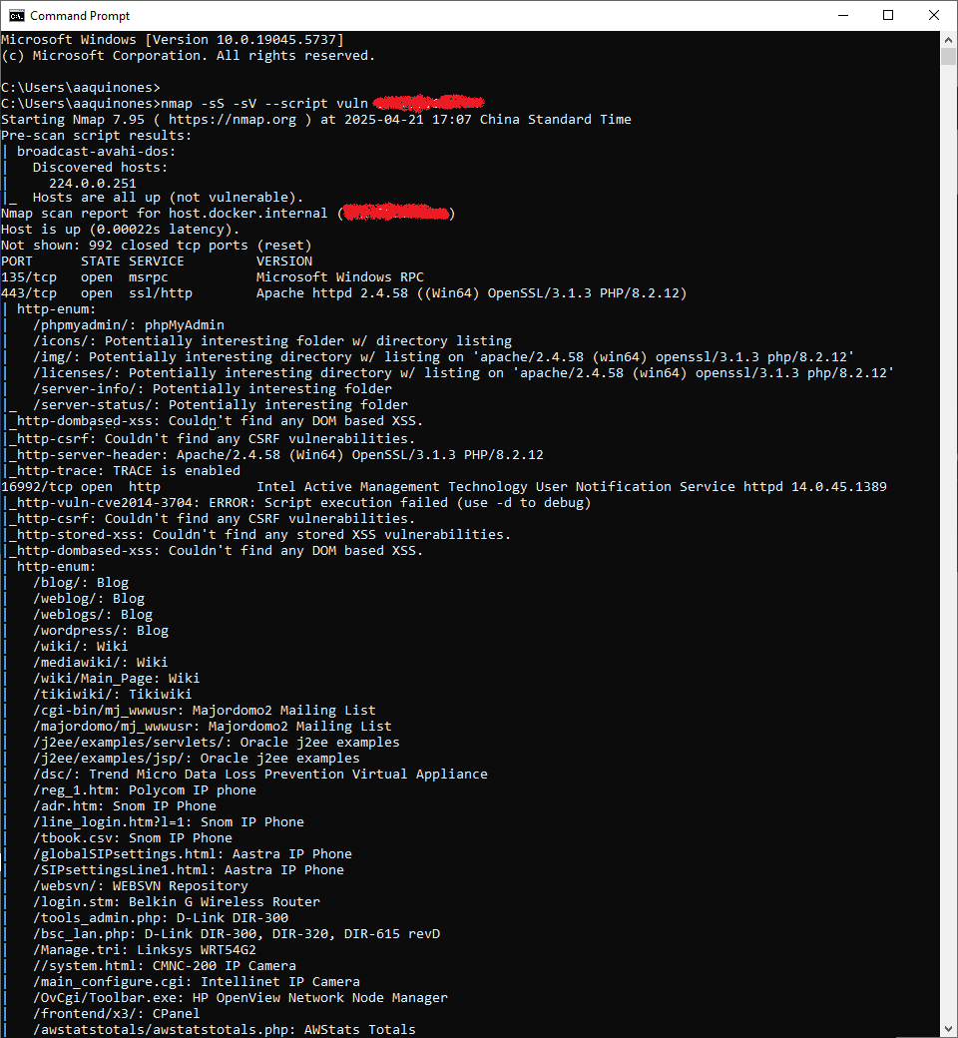

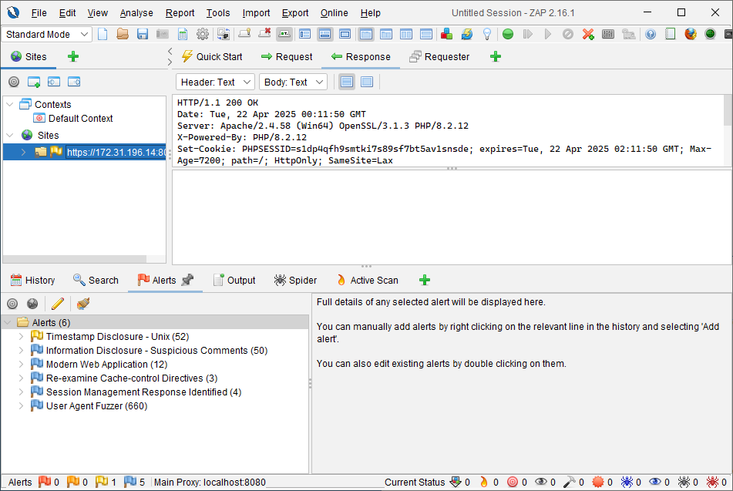

1. **MITIGATION STRATEGIES AND SECURITY POLICIES**

As part of Phase 3 of the security remediation process, the following mitigation strategies and security policies were developed and/or updated to address the identified vulnerabilities, minimize risk exposure, and ensure long-term protection of the system:

1. Mitigation Strategies

|  |  |  |
| --- | --- | --- |
| **Category** | **Vulnerability Addressed** | **Mitigation Strategy** |
| **Web Application Security** | Vulnerable JS Libraries, Missing Security Headers, CSRF, Clickjacking | - Updated all outdated libraries using CDN versions - Enforced secure HTTP response headers via .htaccess and httpd.conf - Enabled CSRF protection in server configuration - Implemented proper error handling and custom error pages |
| **Data Protection** | Information Disclosure (X-Powered-By, Debug Mode, Server Version) | - Disabled debug mode in production - Removed server version banners and powered-by headers - Minified JS files and removed developer comments |
| **Access Control** | Session Exposure, Absence of Anti-CSRF Tokens | - Sanitized all session-related outputs (no exposure in JS console) - Implemented CSRF tokens for all forms |
| **Server/Infrastructure** | Open Ports, Service Fingerprinting | - Disabled unused services - Restricted access to necessary ports only (via firewall rules) - Enforced internal-only access to MySQL and Redis |
| **Monitoring & Logging** | Application Errors, Misconfigurations | - Enabled application logging - Integrated Prometheus and Grafana for real-time monitoring and alerts - Regularly audit logs for suspicious activity |

1. Security Policies

|  |  |
| --- | --- |
| **Policy Title** | **Description** |
| **Web Application Security Policy** | Defines secure coding standards (input validation, CSRF/XSS protection), use of HTTPS, required headers (CSP, X-Content-Type-Options), and version management for libraries. |
| **Access Control Policy** | Specifies role-based access control for admin and user levels, password policy enforcement, and session timeout guidelines. |
| **Patch Management Policy** | Requires regular scanning using tools like Nmap and OWASP ZAP, and monthly review of CVEs and dependencies. Hotfix timelines are defined based on risk level. |
| **Network Security Policy** | Details port management strategy, firewall configurations, VPN access, and segregation of services (all ports/and IP should be whitelisted). |
| **Incident Response Policy** | Outlines procedures for breach identification, immediate containment, impact analysis, reporting, and recovery. Logs are preserved for forensic analysis. |
| **Data Backup and Recovery Policy** | Requires encrypted backup of application databases with offsite storage and regular testing of backup integrity.  Conduct regular/scheduled backups:   1. Full backup - every first day of the month 2. Differential Backup - daily at 6pm   Conduct a backup quarterly integrity:   1. Generate MD5 Sub of all backup files 2. Check backup integrity using md5Sum checker |
| **Audit and Compliance Policy** | Obtain ISO Certifications:   * Database Management Standards * Network & Security Standards * Server Maintenance standards * Predictive Maintenance * Corrective Maintenance * Preventive Maintenance   Establishes annual internal audits and annual external security audits to validate compliance with industry standards like OWASP Top 10. |
|  |  |